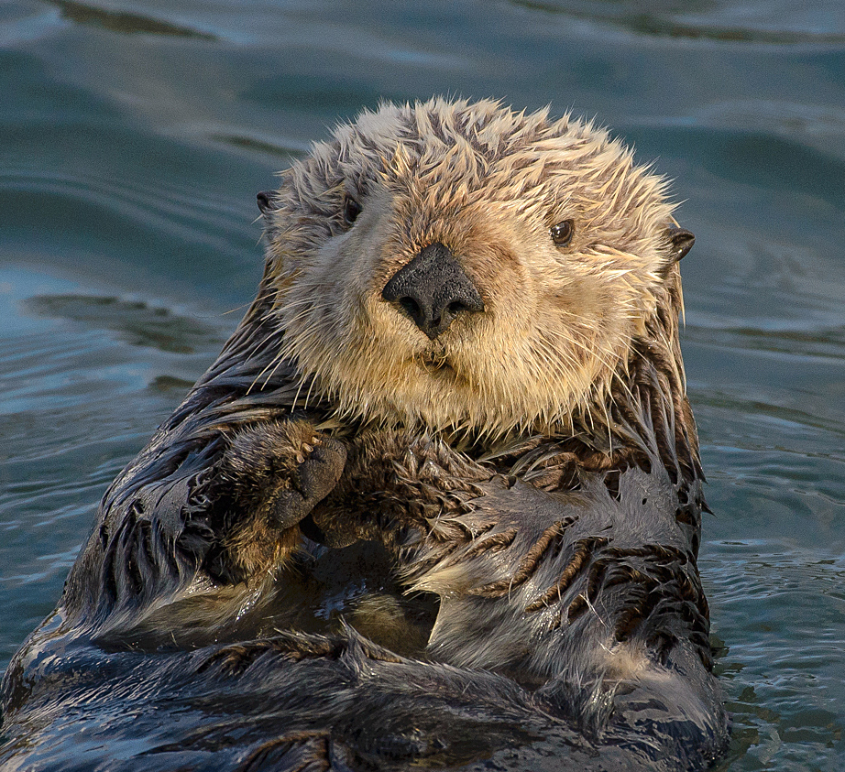

Dear Sea Otter Parents,

A very warm welcome to all our students and families in EY1 Sea Otter class!

It is going to be an exciting year, filled with interesting and fun learning opportunities that will encourage your child to blossom, grow and make friends with children from around the world. Please ensure that you regularly visit the DBIS Hub & Parent Portal as important information will be posted here.

The Sea Otter Team
Hello, my name is Ruth Brislen-Patel and I am the Sea Otter Class Teacher. I am originally from Cheshire, in the UK. At University I completed a BA Honours degree in Education Studies and Psychology from the University of Wales Institute Cardiff. I then completed a School Direct PGCE at the University of Derby, specialising in ages 3 to 7. Before teaching at DBIS, I worked in the UK as a Reception Class Teacher in Stoke-on-Trent. I moved to Hong Kong in 2016 and I have since taught both Nursery and Reception at DBIS these past six years. I am incredibly excited to be in EY1 this year and I look forward to getting to know all the Sea Otter families for a fantastic year full of joy, wonder and discovery.

Hello, my name is Brenda Dauz and I am the Sea Otter Class Educational Assistant. I come from the Philippines and I have lived here in Hong Kong for 27 years. I have been working at DBIS for almost 11 years, 3 years in Reception and this is my 8th year in EY1. I enjoy working in the Early Years, especially with our lovely Sea Otter children!

Communication
It is extremely important to all the EY1 teachers that we establish a positive home-school partnership. We have exciting plans for the year and we will let you know what they are through the DBIS Parent Hub and classroom communication boards, so please keep checking all the communications regularly. Should you wish to discuss your child's learning or any sensitive issues in greater detail, please do not hesitate to contact your child's class teacher or Ms Brislen-Patel (EY1 Year Group Leader) to arrange a meeting at a mutually agreed time. If you wish to use email, then please send any communication for the attention of the appropriate teacher through the school office: dbis@dbis.edu.hk You can also use the messaging function on Seesaw to directly message your class teacher, these will be responded to within 24 hours during the school week.

The School Day
Our classroom doors open from 8.25am each morning, please show your child’s temperature & RAT card to the teacher at the door before your child enters the classroom. We expect children to independently come into the classroom, put their belongings away and begin their learning. Due to current restrictions, we are unable to welcome parents into the classroom each morning, we encourage parents and carers to say goodbye to their child at the door. We ask you to understand that we would like to stay and chat when the bell rings, but the children are our first priority. The school day will finish for EY1 children at 3.10pm. Masks must be worn at all times when entering the school campus. EY1 families can enter campus via the EY1 side gate, please remember to scan the Leave Home Safe App and bring your Parent ID Card with you for pick up time. Any parents and carers without a Parent ID card will be required to sign children out from the main office. If your child is unwell please communicate absences through the DBIS Hub jotform: https://form.jotform.me/72201104115435

What your child needs:

- DBIS School Bag (Please keep spare underwear and clothes in case of accidents)
- DBIS School Hat
- Named wellighton Boots & Rain Coat for Outdoor Learning
- Water Bottle (Clearly labelled with name. No metal water bottles to be brought to school.)
- Spare Masks
- 1 named A4 plastic folders for home reader book and Library books
- A small snack e.g apple (in a container they can open independently labelled with your child’s name and class)
- Named lunch box (labelled with your child’s name and class - unless your child is eating at the cafeteria)

Healthy Lunches and Snacks
EY1 Snack takes place at 10am during outdoor break and Lunch takes place at 11:55am. If you would like you child to eat lunch in the cafeteria please contact dbis@dbis.edu.hk If your child is having a packed lunch this should be placed in the boxes provided outside each class. To promote health and wellbeing, we encourage all students to make healthy choices for their snacks and lunches. Sweets, candy, fizzy soda pop/soft drinks and chewing gum are not allowed at school. Please also be aware that we are a Nut Aware school and we kindly ask that no products containing nuts or that may contain traces of nuts are brought onto the school premises. (This includes store-bought pesto: pine nuts) If your child has an allergy that you feel is of concern to their safety, please speak with your child’s class teacher.

School Uniform
Please ensure your child is wearing the appropriate and correct uniform to school each day. Details of this can be found on the DBIS Hub. Hats must be brought to school every day as students must wear these during breaks and lunchtimes, otherwise, they will be unable to play on the playground. Students with long hair are requested to tie it back for health and safety reasons.

Specialist Lessons: On PE (Physical Education) day, students must wear the DBIS PE Kit
PE | Mandarin | Library | Music | Learning Technologies
Monday, Thursday | Tuesday, Thursday, Friday | Wednesday | Tuesday | Thursday

Swimming
Please be aware that EY1 students will begin the swimming program during Term 1. Further information regarding the dates and times will follow.

Essential items:
Students will need the following items once swimming commences. Please ensure that these are clearly labelled with your child's name.

- DBIS rash vest with DBIS swim shorts (The DBIS swimming costume is also available, however for ease of changing and use of the toilet we advise the DBIS rash vest and swim shorts for all students)
- DBIS swimming cap (house colours)
- Adjustable goggles
- Flip flops/crocs
- A towel
- Waterproof/plastic bag for wet things
- Underwear and uniform (if wearing swimming kit to school) this applies to lessons before Snack Time only

Outdoor & Experiential Learning Experiences
We value the importance of Outdoor and Experiential learning opportunities at DBIS. In the coming weeks, we will communicate further information about Forest School and Woodwork opportunities for your child. In preparation for this, we kindly ask you to bring rain boots and a raincoat to be kept in school. EY1 students have multiple opportunities to explore outside learning areas, it is useful to apply sunscreen and insect repellent before school. We will reapply sunscreen and insect repellent as necessary, if you do not wish for your child to use the provided sunscreen or insect repellent (RID) please speak to your child's class teacher.

We are really looking forward to getting to know all our Sea Otter families. Please do not hesitate to contact us if you have any questions. Thank you for your support and we look forward to working in partnership with you.

Kind Regards,

Ms Brislen-Patel & Mrs Dauz

